***For your local place and your contrasting place, evaluate the view that low income is the most important factor leading to deprivation. (20)***

The degree to which an individual or an area is deprived of services and amenities. There are many different types and levels of deprivation included poor and overcrowded housing, inadequate diet, inadequate income and lack of opportunity for employment.

**Para 1**

Income in Newnham

* Average Salary £43.6k
* Average House Price - £1,051,868

High income and cost of living = low levels of deprivation

**Para 2**

Income in Anfield

* Average House Price - £94,176
* Average Salary - £34.8k

**Other factors effecting deprivation**

**Para 3**

**Crime in Anfield vs Newnham**

Anfield – 955 crimes July 2021. Largest category - Violent Crime, followed by Public Order.

Newnham - 85 criminal acts July 2021. Largest Category - Violent Crime and Anti-Social behaviour

Crime rate may link to deprivation and income

**Para 4**

**Education**

**Newnham –** Good state schools inc hills road and great private schools

**Anfield –** Only two primary schools in direct area but with access to other sub par seconday schools

**Para 5**

**Government Regeneration Schemes**

Train station -

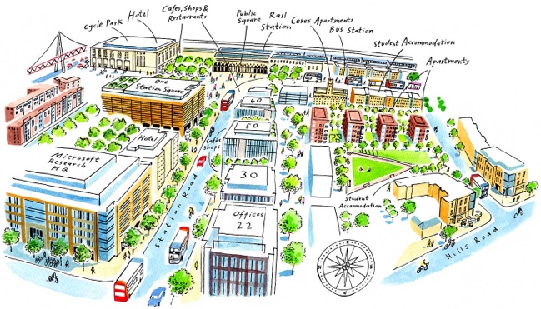

Anfield Project - include the expansion of Anfield Stadium, new and refurbished housing and the development of a new public square including commercial and retail premises and a revitalised high street.

**Conclusion**

Low income is the most important factor leading to deprivation